

REDUCED DOWNTIME AND IMPROVE MAINTENANCE
The Engine Eye will be a powerful tool for periodic or prolonged measurement, provides misfiring analysis, and will be accompanied by a user friendly PC application, which allows the user to analyze and store the collected data.

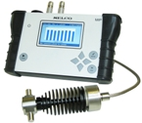

Robust, Reliable, Ready for Release in 2011.

